2.1.1 Roots of Quadratic Equation
ALGORITHM
- Start
- Import the math library.
- Read three integers a, b, and c (coefficients of the quadratic equation).
- Calculate the discriminant
$D=b^{2}-4ac$
5. If D > 0:
Calculate two real and different roots using:
$\frac{-b+\sqrt{D}}{2a},\frac{-b-\sqrt{D}}{2a}$
Print both roots up to 2 decimal places.
- Else if D == 0:
Calculate the single repeated root:
$$\frac{-b}{2a}$$
Print the root twice up to 2 decimal places.
- Else (D < 0):
Calculate real part:
$$\frac{-b}{2a}$$
Calculate imaginary part:
$$\frac{\sqrt{-D}}{2a}$$
Print both complex roots up to 2 decimal places.
- Stop

FLOWCHART
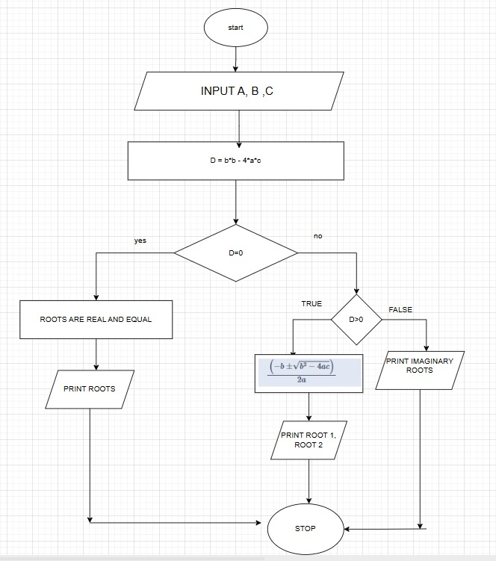
PROGRAM
